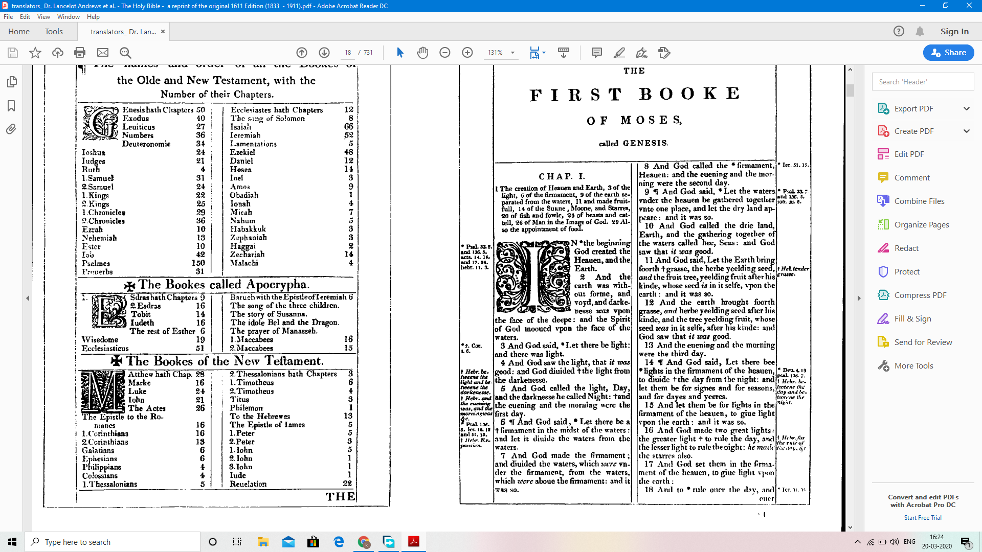

| **Chapter 1**  [1:1] In the beginning when God created the heavens and the earth,  [1:2] the earth was a formless void and darkness covered the face of the deep, while a wind from God swept over the face of the waters.  [1:3] Then God said, "Let there be light"; and there was light.  [1:4] And God saw that the light was good; and God separated the light from the darkness.  [1:5] God called the light Day, and the darkness he called Night. And there was evening and there was morning, the first day.  [1:6] And God said, "Let there be a dome in the midst of the waters, and let it separate the waters from the waters."  [1:7] So God made the dome and separated the waters that were under the dome from the waters that were above the dome. And it was so.  [1:8] God called the dome Sky. And there was evening and there was morning, the second day.  [1:9] And God said, "Let the waters under the sky be gathered together into one place, and let the dry land appear." And it was so.  [1:10] God called the dry land Earth, and the waters that were gathered together he called Seas. And God saw that it was good.  [1:11] Then God said, "Let the earth put forth vegetation: plants yielding seed, and fruit trees of every kind on earth that bear fruit with the seed in it." And it was so.  [1:12] The earth brought forth vegetation: plants yielding seed of every kind, and trees of every kind bearing fruit with the seed in it. And God saw that it was good.  [1:13] And there was evening and there was morning, the third day.  [1:14] And God said, "Let there be lights in the dome of the sky to separate the day from the night; and let them be for signs and for seasons and for days and years,  [1:15] and let them be lights in the dome of the sky to give light upon the earth." And it was so.  [1:16] God made the two great lights - the greater light to rule the day and the lesser light to rule the night - and the stars.  [1:17] God set them in the dome of the sky to give light upon the earth,  [1:18] to rule over the day and over the night, and to separate the light from the darkness. And God saw that it was good.  [1:19] And there was evening and there was morning, the fourth day.  [1:20] And God said, "Let the waters bring forth swarms of living creatures, and let birds fly above the earth across the dome of the sky."  [1:21] So God created the great sea monsters and every living creature that moves, of every kind, with which the waters swarm, and every winged bird of every kind. And God saw that it was good.  [1:22] God blessed them, saying, "Be fruitful and multiply and fill the waters in the seas, and let birds multiply on the earth."  [1:23] And there was evening and there was morning, the fifth day.  [1:24] And God said, "Let the earth bring forth living creatures of every kind: cattle and creeping things and wild animals of the earth of every kind." And it was so.  [1:25] God made the wild animals of the earth of every kind, and the cattle of every kind, and everything that creeps upon the ground of every kind. And God saw that it was good.  [1:26] Then God said, "Let us make humankind in our image, according to our likeness; and let them have dominion over the fish of the sea, and over the birds of the air, and over the cattle, and over all the wild animals of the earth, and over every creeping thing that creeps upon the earth."  [1:27] So God created humankind in his image, in the image of God he created them; male and female he created them.  [1:28] God blessed them, and God said to them, "Be fruitful and multiply, and fill the earth and subdue it; and have dominion over the fish of the sea and over the birds of the air and over every living thing that moves upon the earth."  [1:29] God said, "See, I have given you every plant yielding seed that is upon the face of all the earth, and every tree with seed in its fruit; you shall have them for food.  [1:30] And to every beast of the earth, and to every bird of the air, and to everything that creeps on the earth, everything that has the breath of life, I have given every green plant for food." And it was so.  [1:31] God saw everything that he had made, and indeed, it was very good. And there was evening and there was morning, the sixth day.  **Chapter 2**  [2:1] Thus the heavens and the earth were finished, and all their multitude.  [2:2] And on the seventh day God finished the work that he had done, and he rested on the seventh day from all the work that he had done.  [2:3] So God blessed the seventh day and hallowed it, because on it God rested from all the work that he had done in creation.  [2:4] These are the generations of the heavens and the earth when they were created. In the day that the LORD God made the earth and the heavens,  [2:5] when no plant of the field was yet in the earth and no herb of the field had yet sprung up - for the LORD God had not caused it to rain upon the earth, and there was no one to till the ground;  [2:6] but a stream would rise from the earth, and water the whole face of the ground -  [2:7] then the LORD God formed man from the dust of the ground, and breathed into his nostrils the breath of life; and the man became a living being.  [2:8] And the LORD God planted a garden in Eden, in the east; and there he put the man whom he had formed.  [2:9] Out of the ground the LORD God made to grow every tree that is pleasant to the sight and good for food, the tree of life also in the midst of the garden, and the tree of the knowledge of good and evil.  [2:10] A river flows out of Eden to water the garden, and from there it divides and becomes four branches.  [2:11] The name of the first is Pishon; it is the one that flows around the whole land of Havilah, where there is gold;  [2:12] and the gold of that land is good; bdellium and onyx stone are there.  [2:13] The name of the second river is Gihon; it is the one that flows around the whole land of Cush.  [2:14] The name of the third river is Tigris, which flows east of Assyria. And the fourth river is the Euphrates.  [2:15] The LORD God took the man and put him in the garden of Eden to till it and keep it.  [2:16] And the LORD God commanded the man, "You may freely eat of every tree of the garden;  [2:17] but of the tree of the knowledge of good and evil you shall not eat, for in the day that you eat of it you shall die."  [2:18] Then the LORD God said, "It is not good that the man should be alone; I will make him a helper as his partner."  [2:19] So out of the ground the LORD God formed every animal of the field and every bird of the air, and brought them to the man to see what he would call them; and whatever the man called every living creature, that was its name.  [2:20] The man gave names to all cattle, and to the birds of the air, and to every animal of the field; but for the man there was not found a helper as his partner.  [2:21] So the LORD God caused a deep sleep to fall upon the man, and he slept; then he took one of his ribs and closed up its place with flesh.  [2:22] And the rib that the LORD God had taken from the man he made into a woman and brought her to the man.  [2:23] Then the man said, "This at last is bone of my bones and flesh of my flesh; this one shall be called Woman, for out of Man this one was taken."  [2:24] Therefore a man leaves his father and his mother and clings to his wife, and they become one flesh.  [2:25] And the man and his wife were both naked, and were not ashamed.  **Chapter 3**  [3:1] Now the serpent was more crafty than any other wild animal that the LORD God had made. He said to the woman, "Did God say, 'You shall not eat from any tree in the garden'?"  [3:2] The woman said to the serpent, "We may eat of the fruit of the trees in the garden;  [3:3] but God said, 'You shall not eat of the fruit of the tree that is in the middle of the garden, nor shall you touch it, or you shall die. '"  [3:4] But the serpent said to the woman, "You will not die;  [3:5] for God knows that when you eat of it your eyes will be opened, and you will be like God, knowing good and evil."  [3:6] So when the woman saw that the tree was good for food, and that it was a delight to the eyes, and that the tree was to be desired to make one wise, she took of its fruit and ate; and she also gave some to her husband, who was with her, and he ate.  [3:7] Then the eyes of both were opened, and they knew that they were naked; and they sewed fig leaves together and made loincloths for themselves.  [3:8] They heard the sound of the LORD God walking in the garden at the time of the evening breeze, and the man and his wife hid themselves from the presence of the LORD God among the trees of the garden.  [3:9] But the LORD God called to the man, and said to him, "Where are you?"  [3:10] He said, "I heard the sound of you in the garden, and I was afraid, because I was naked; and I hid myself."  [3:11] He said, "Who told you that you were naked? Have you eaten from the tree of which I commanded you not to eat?"  [3:12] The man said, "The woman whom you gave to be with me, she gave me fruit from the tree, and I ate."  [3:13] Then the LORD God said to the woman, "What is this that you have done?" The woman said, "The serpent tricked me, and I ate."  [3:14] The LORD God said to the serpent, "Because you have done this, cursed are you among all animals and among all wild creatures; upon your belly you shall go, and dust you shall eat all the days of your life.  [3:15] I will put enmity between you and the woman, and between your offspring and hers; he will strike your head, and you will strike his heel."  [3:16] To the woman he said, "I will greatly increase your pangs in childbearing; in pain you shall bring forth children, yet your desire shall be for your husband, and he shall rule over you."  [3:17] And to the man he said, "Because you have listened to the voice of your wife, and have eaten of the tree about which I commanded you, 'You shall not eat of it,' cursed is the ground because of you; in toil you shall eat of it all the days of your life;  [3:18] thorns and thistles it shall bring forth for you; and you shall eat the plants of the field.  [3:19] By the sweat of your face you shall eat bread until you return to the ground, for out of it you were taken; you are dust, and to dust you shall return."  [3:20] The man named his wife Eve, because she was the mother of all living.  [3:21] And the LORD God made garments of skins for the man and for his wife, and clothed them.  [3:22] Then the LORD God said, "See, the man has become like one of us, knowing good and evil; and now, he might reach out his hand and take also from the tree of life, and eat, and live forever"--  [3:23] therefore the LORD God sent him forth from the garden of Eden, to till the ground from which he was taken.  [3:24] He drove out the man; and at the east of the garden of Eden he placed the cherubim, and a sword flaming and turning to guard the way to the tree of life. |
| --- |